

**Software engineering assignment #1**

**Sec:** A

**Names/roll:**

1. Senan Faisal 21i-1546
2. Muneeb Akhtar 21i-0520
3. Moaz sami 22i-

**Instructor:** Javaria Imtiaz

**Project: “**MechSense”

**Problem statement:**

|  |  |
| --- | --- |
| **The problem of** | unexpected vehicle breakdowns and inefficient maintenance practices |
| **affects** | everyday car owners, mechanics, and car rental businesses |
| **the impact of which is** | frustration, high repair costs, and difficulty in identifying issues before they turn into major problems |
| **a successful solution would be** | a smart, AI-powered vehicle monitoring system that helps users keep their cars in top condition. By analyzing sensor data in real-time, the system can detect potential issues early, provide easy-to-understand diagnostics, and send timely maintenance reminders. This proactive approach not only saves money but also ensures a safer and smoother driving experience. Additionally, the system can connect users with professional mechanics for expert advice, making vehicle maintenance more convenient and stress-free. |

**Features:**

1. **Vehicle Health Monitoring**

Track engine performance, battery status, and fuel efficiency.

1. **Fault Detection & Alerts**

Identify mechanical issues and notify the user in real-time.

1. **Maintenance Reminders**

Schedule service and oil change alerts based on usage.

1. **Driving Behavior Analysis**

Monitor speed, braking patterns, and fuel consumption.

1. **Trip History & Analytics**

View past trips, mileage, and driving efficiency stats.

1. **Remote Vehicle Diagnostics**

Scan and analyze vehicle issues via a mobile app.

1. **Smart Notifications**

Receive alerts for low fuel, tire pressure, or emergency situations

1. **User-Friendly Dashboard**

Access all data through an intuitive, easy-to-use interface.

1. **Integration with Mechanic Services**

Suggest nearby mechanics based on detected issues.

1. **Data Export & Reports**

Generate reports for insurance claims or vehicle resale value.

**Product Backlog:**

**1)**

|  |  |
| --- | --- |
| **Story title:** | Vehicle Health Monitoring |
| **User story** | As a vehicle owner I want to monitor my car’s health in real-time So that I can prevent breakdowns and optimize maintenance costs |
| **Acceptance criteria** | The system displays real-time engine, battery, and fuel efficiency data |

**2)**

|  |  |
| --- | --- |
| **Story title:** | ****Fault Detection & Alerts**** |
| **User story** | As a vehicle owner I want to receive fault alerts when my vehicle has mechanical issues So that I can take quick action and avoid costly repairs |
| **Acceptance criteria** | The app sends notifications when an issue is detected |

**3)**

|  |  |
| --- | --- |
| **Story title:** | ****. Maintenance Reminders**** |
| **User story** | **As a** car owner **I want** to receive alerts for scheduled maintenance **So that** I can keep my car in optimal condition |
| **Acceptance criteria** | The app notifies users based on mileage or time intervals |

**4)**

|  |  |
| --- | --- |
| **Story title:** | ****Driving Behaviour Analysis**** |
| **User story** | **As a** driver **I want** to track my driving habits **So that** I can improve fuel efficiency and driving safety |
| **Acceptance criteria** | The system provides analytics on speed, braking, and acceleration patterns |

**5)**

|  |  |
| --- | --- |
| **Story title:** | ****Trip History & Analytics**** |
| **User story** | **As a** driver **I want** to view my past trips and mileage **So that** I can analyze my driving performance |
| **Acceptance criteria** | The app displays trip summaries, including distance, speed, and fuel consumption |

**6)**

|  |  |
| --- | --- |
| **Story title:** | ****Remote Vehicle Diagnostics**** |
| **User story** | **As a** car owner **I want** to scan my vehicle for issues remotely **So that** I can diagnose problems without visiting a mechanic |
| **Acceptance criteria** | The system provides error codes and suggested fixes |

**7)**

|  |  |
| --- | --- |
| **Story title:** | ****Smart Notifications**** |
| **User story** | **As a** vehicle owner **I want** to receive important alerts (low fuel, battery health, tire pressure) **So that** I can avoid unexpected issues while driving |
| **Acceptance criteria** | The app sends push notifications for critical alerts |

**8)**

|  |  |
| --- | --- |
| **Story title:** | ****User-Friendly Dashboard**** |
| **User story** | **As a** driver **I want** a clean and intuitive dashboard **So that** I can access all necessary vehicle data easily |
| **Acceptance criteria** | The UI should be simple, with essential metrics visible at a glance |

**9)**

|  |  |
| --- | --- |
| **Story title:** | ****Integration with Mechanic Services**** |
| **User story** | **As a** driver **I want** to find nearby mechanics when my car breaks down **So that** I can get repairs quickly |
| **Acceptance criteria** | The app suggests mechanics based on issue type and location |

**10)**

|  |  |
| --- | --- |
| **Story title:** | ****Data Export & Reports**** |
| **User story** | **As a** car owner **I want** to export my vehicle history and diagnostics **So that** I can provide data to insurance companies or buyers |
| **Acceptance criteria** | Users can generate and download vehicle reports |

**11)**

|  |  |
| --- | --- |
| **Story title:** | ****Fuel Consumption Analysis**** |
| **User story** | **As a** driver **I want** to track my fuel usage **So that** I can optimize my fuel efficiency |
| **Acceptance criteria** | The system provides fuel consumption insights per trip |

**12)**

|  |  |
| --- | --- |
| **Story title:** | ****Battery Health Monitoring**** |
| **User story** | **As a** car owner **I want** to check my battery status **So that** I can replace it before failure |
| **Acceptance criteria** | The app shows battery voltage and estimated lifespan |

**13)**

|  |  |
| --- | --- |
| **Story title:** | ****Tire Pressure Monitoring**** |
| **User story** | **As a** driver **I want** to receive alerts about low tire pressure **So that** I can maintain optimal vehicle performance |
| **Acceptance criteria** | The system warns users when pressure drops below safe levels |

**14)**

|  |  |
| --- | --- |
| **Story title:** | ****Emergency Assistance**** |
| **User story** | **As a** driver **I want** to request roadside assistance **So that** I can get immediate help if my car breaks down |
| **Acceptance criteria** | Users can call for help through the app |

**15)**

|  |  |
| --- | --- |
| **Story title:** | ****Parking Location Reminder**** |
| **User story** | **As a** car owner **I want** to save my parking location **So that** I can easily find my car |
| **Acceptance criteria** | The app marks the last parked location on a map |

**16)**

|  |  |
| --- | --- |
| **Story title:** | ****Speed Limit Alerts**** |
| **User story** | **As a** driver **I want** to receive speed alerts **So that** I can avoid traffic fines |
| **Acceptance criteria** | The app alerts the driver when exceeding speed limits |

**17)**

|  |  |
| --- | --- |
| **Story title:** | ****Integration with Smart Assistants**** |
| **User story** | **As a** driver **I want** to use voice commands to check my vehicle status **So that** I can get information hands-free |
| **Acceptance criteria** | The app integrates with Alexa, Google Assistant, and Siri |

**18)**

|  |  |
| --- | --- |
| **Story title:** | ****Multi-User Access**** |
| **User story** | **As a** family **I want** multiple users to access the same vehicle data **So that** all drivers can monitor the car’s health |
| **Acceptance criteria** | The system allows multiple profiles for one vehicle |

**19)**

|  |  |
| --- | --- |
| **Story title:** | ****Theft Detection & Alerts**** |
| **User story** | **As a** car owner **I want** to receive an alert if my car is moved without permission **So that** I can take immediate action |
| **Acceptance criteria** | The system detects unauthorized movement and sends alerts |

**20)**

|  |  |
| --- | --- |
| **Story title:** | ****Geofencing for Young Drivers**** |
| **User story** | **As a** parent **I want** to set geographical driving limits **So that** I can ensure my teen driver’s safety |
| **Acceptance criteria** | The app alerts when the vehicle exits a defined area |

**21)**

|  |  |
| --- | --- |
| **Story title:** | ****Real-time Weather Impact Analysis**** |
| **User story** | **As a** driver **I want** to know how weather affects my vehicle performance **So that** I can take necessary precautions |
| **Acceptance criteria** | The app provides weather-based driving tips |

**22)**

|  |  |
| --- | --- |
| **Story title:** | ****Insurance Claim Assistance**** |
| **User story** | **As a** car owner **I want** to auto-generate reports for insurance claims **So that** I can speed up the claim process |
| **Acceptance criteria** | The app generates and shares claim-related documents |

**23)**

|  |  |
| --- | --- |
| **Story title:** | ****Rental & Fleet Management**** |
| **User story** | **As a** business owner **I want** to track multiple vehicles in my fleet **So that** I can optimize their usage |
| **Acceptance criteria** | The system supports multiple vehicle tracking |

**24)**

|  |  |
| --- | --- |
| **Story title:** | ****Predictive Maintenance Alerts**** |
| **User story** | **As a** driver **I want** predictive maintenance insights **So that** I can fix problems before they happen |
| **Acceptance criteria** | The system predicts upcoming failures based on usage patterns |

**25)**

|  |  |
| --- | --- |
| **Story title:** | ****Carpooling & Ride Sharing Integration**** |
| **User story** | **As a** commuter **I want** to share my ride details **So that** I can coordinate with friends or family |
| **Acceptance criteria** | The app allows ride-sharing trip scheduling |

**Scrum Roles & Responsibilities**

#### ****Moaz Sami (Product Owner)****

* Defines the vision and goals
* Prioritizes backlog items
* Ensures the product meets business needs
* Communicates with stakeholders

#### ****2. Senan Faisal (Scrum Master)****

* Facilitates daily stand-ups & sprint planning
* Removes blockers for the team
* Ensures Agile practices are followed
* Helps the team improve processes

#### ****3. Muneeb Akhtar (Scrum Team, Developer/QA)****

* Develops and tests the application features
* Writes and maintains code
* Participates in sprint reviews and retrospectives
* Ensures quality and functionality

# **Team Agreement**

## **1. Methods of Communication**

To ensure smooth collaboration, the team will use multiple communication methods based on the nature of discussions:

* **Primary Communication:** Slack (for daily discussions, sharing updates, and quick questions)
* **Formal Communication:** Email (for official documentation, reports, and formal requests)
* **Urgent Communication:** Phone calls or WhatsApp (for immediate concerns or urgent clarifications)
* **Scheduled Discussions:** Zoom or Microsoft Teams (for structured meetings and discussions)

## **2. Communication Response Times**

Timely communication is essential for efficiency. The expected response times for different methods are:

* **Slack Messages:** Within 4 hours during work hours (9 AM – 6 PM)
* **Emails:** Within 24 hours (for non-urgent matters)
* **Phone Calls/WhatsApp:** Immediate response for emergencies, otherwise within 2 hours
* **Meeting Invitations/Notices:** At least 2 days' prior notice

## **3. Meeting Attendance**

* Regular meetings will be scheduled **weekly on Wednesdays at 5 PM (UTC)**.
* All members are expected to attend meetings unless they have a valid reason.
* Emergency meetings may be scheduled as needed.
* If a member cannot attend, they must notify the team at least 24 hours in advance.
* Persistent absenteeism without valid reasons will be addressed.

## **4. Running Meetings**

* Meetings will be conducted via **Zoom** unless otherwise decided.
* A designated **Meeting Coordinator** will rotate among team members to ensure fairness.
* **Agenda:** Shared 24 hours before the meeting to allow preparation.
* **Minutes/Notes:** The assigned note-taker will document key discussions, decisions, and action items.
* **Meeting Duration:** Meetings will not exceed 1 hour to ensure efficiency.

## **5. Meeting Preparation**

* Team members must review the **agenda and relevant materials** before attending.
* If assigned to present or report on a task, members should be prepared in advance.
* Pre-meeting preparation is expected for technical discussions to ensure informed decision-making.

## **6. Version Control**

* **Platform:** GitHub will be used for version control.
* **Commit Rules:**
  + Only functional and tested code will be committed to the main branch.
  + Meaningful commit messages should be provided (e.g., "Fixed login bug" instead of "Updated file").
* **Branching Strategy:**
  + Main branch for stable releases.
  + Feature branches for development.
  + Pull requests must be reviewed before merging.
* **Documentation:** Every major feature must include a README or relevant documentation update.

## **7. Division of Work**

* Work will be divided based on skillsets, availability, and project requirements.
* Tasks will be assigned and tracked using **Trello** or **Jira**.
* Team members can request task reassignment if they struggle with a particular area.
* **Stakeholders:** Project lead, client (if applicable), team members, and academic supervisors.

## **8. Submitting Assignments**

* Deadlines will be set **at least 24 hours before the actual submission deadline** to allow review.
* A **Review Team** (rotating responsibility) will verify quality and compliance.
* The final submission will be done by a **designated team member** after approval from the majority.
* No last-minute changes will be allowed without consensus.

## **9. Contingency Planning**

* **If a team member drops out:** Work will be redistributed among remaining members, and a replacement will be sought if possible.
* **If a team member consistently misses meetings:** They will receive one formal warning; continued absence will be escalated to the academic supervisor.
* **If a team member is academically dishonest:** The issue will be discussed internally first. If unresolved, the matter will be reported to the relevant authority.
* **If a critical deadline is missed:** Emergency meetings will be called to adjust workloads and priorities.

**Sprint Backlog**

### **Sprint Duration:** 3 Weeks

### **Sprint Goal:** Develop and implement core features of the project while ensuring smooth collaboration and quality assurance.

|  |  |  |  |  |  |
| --- | --- | --- | --- | --- | --- |
| ID | User Story | Task Breakdown | Assignee | Priority | Status |
| PBI-01 | As a user, I want to sign up and log in so that I can access my personalized dashboard. | - Design authentication UI  - Implement Firebase authentication  - Validate inputs and errors | Moaz Sami | High | In progress |
| PBI-02 | As a user, I want to browse available products/services so that I can make a selection. | Implement product catalog UI  - Fetch product data from the database  - Optimize for performance | Senan Faisal | High | To do |
| PBI-03 | As a user, I want to add items to my cart so that I can place an order. | - Develop "Add to Cart" functionality  - Implement cart UI  - Store selected items temporarily | Muneeb Akhtar | High | To do |
| PBI-04 | As a user, I want to place an order so that I can purchase items. | Create order placement workflow  - Implement checkout page  - Integrate with payment gateway | |  | | --- | | Moaz Sami |  |  | | --- | |  | | High | To do |
| PBI-05 | As an admin, I want to manage product inventory so that I can update stock levels. | Build inventory management UI  - Implement CRUD operations  - Ensure role-based access control | Senan faisal | Medium | To do |
| PBI-06 | As a user, I want to track my order status so that I know when it will be delivered. | Implement order tracking UI  - Update order status dynamically  - Notify users of status changes | Muneeb akhtar | medium | To do |
| PBI-07 | As a user, I want to provide feedback so that I can share my experience. | Design feedback form  - Store feedback in the database  - Display user reviews on the platform | Moaz sami | Low | To do |
| PBI-08 | As an admin, I want to view sales reports so that I can analyze business performance. | Develop reports dashboard  - Generate daily, weekly, monthly reports  - Ensure data security | Senan faisal | Low | To do |

**Trello cards snapshots:**

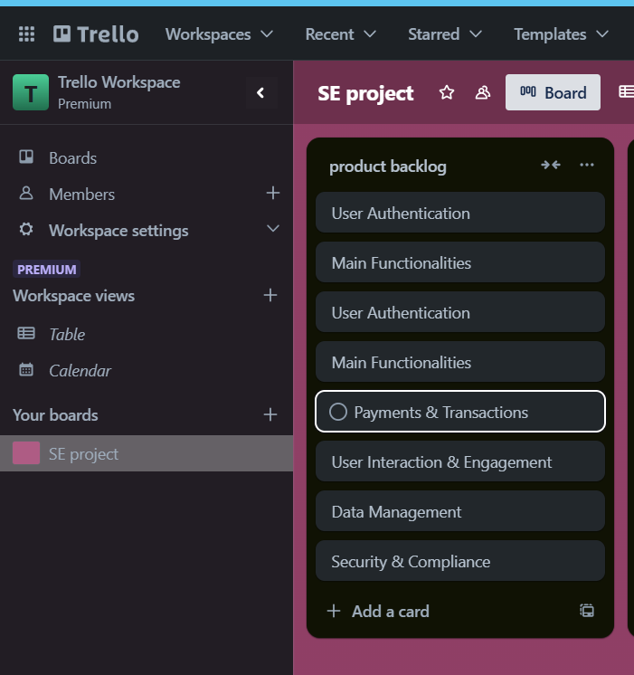

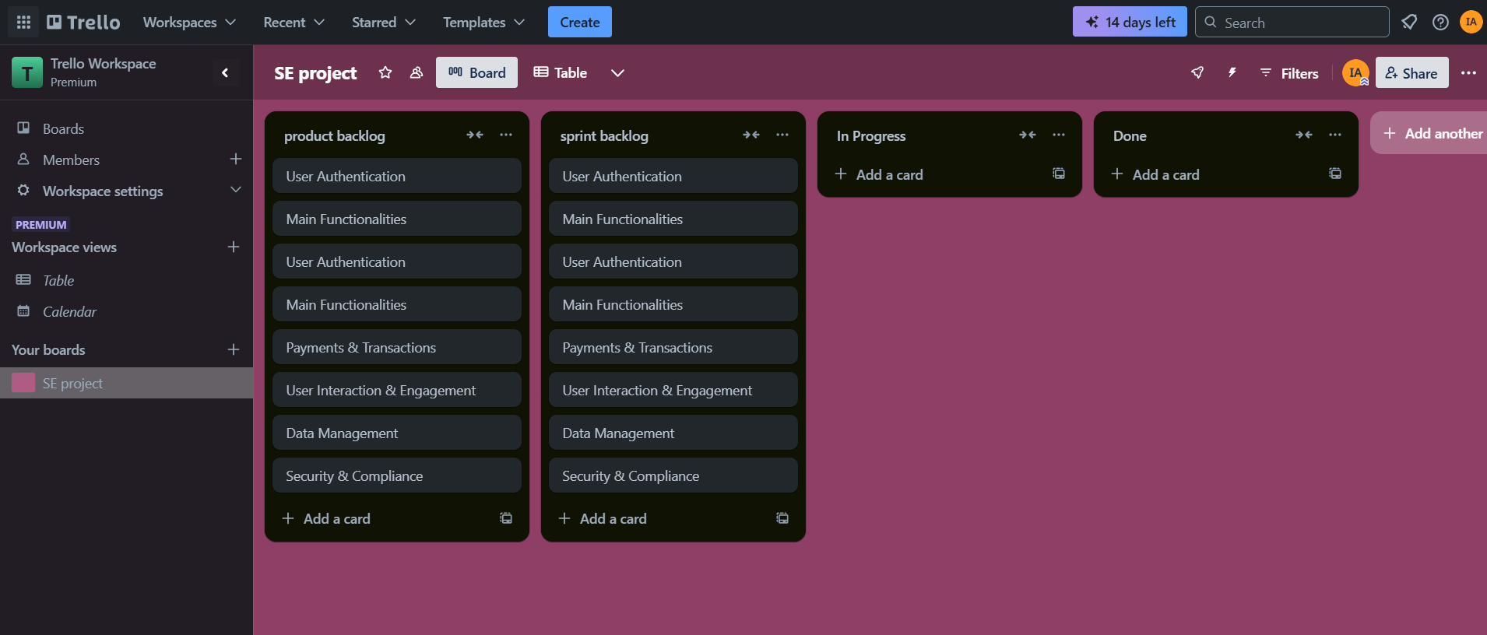

**GitHub snapshot:**